Pokhara University

Level: Bachelor | Semester – Fall | Year : 2009
Programme: B.E. |  | Full Marks : 100
Course: Logic Circuits |  | Time : 3hrs.

Candidates are required to give their answers in their own words as far as practicable.
The figures in the margin indicate full marks.

Attempt all the questions.

1. | - Perform the following operation.  - 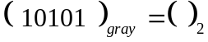  - 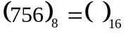  - 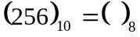  - 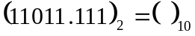  - 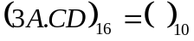  - Use 2's compliment method to subtract the following 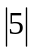  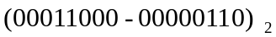  - Explain Digital and Analog systems. Also list out the advantages of digital system over analog. | 5  5  5
2. | - Use K-map to simplify the given Boolean function in POS and implement the simplified function using NOR gate only.  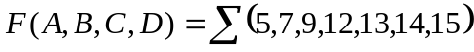,and don't care 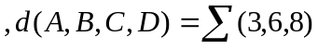  - Design a code converter circuit that can convert a decimal digit from Binary to Excess-3. | 7  8
3. | - Design a comparator circuit that compare two 3 bit numbers. The two numbers being A and B. it is required to obtain three possible outcomes i.e. A>B, A<B and A=B.  - Implement the full adder circuit using two 4:1 MUX. | 7  8
4. | - Design a combinational circuit to check for even parity of four bits. A logic 1 output is required when the four bits do not constitute an even number of one.  - Explain the operation of a clocked RS flipflop with the help of this characteristic table. What are the drawbacks of this flipflop? Produce its characteristic table. Write down the characteristics equation and graphic symbol for the same. | 7  8
5. | - Discuss the purpose of register. Explain serial in parallel out shift register.  - Design a code conversion circuit to convert BCD code to Gray code. | 8  7
6. | - Design a 2-bit synchronous up counter using J-K flipflop.  - Design a 4 bit arithmetic circuit with two selection variables are S1 & SO that generates the following arithmetic operations. | 8  7
  S1 S0 | Cin=0 | Cin=1
  0 0 | A | A+1
  0 1 | A+B | A+B+1
  1 0 | A+B' | A+B'+1
  1 1 | A-1 | A
7 | Write short notes on (Any Two)  - Tri state Logic  - State table and state diagram  - De-Morgans theorem | 5x2

